Property Development Process in the late 19th century in Pangalti-Sisli

Istanbul, similar to other metropolises in Europe in the 19th century, had a population expansion and was facing a housing crisis, although neither the population increase nor the housing crisis was as severe as the ones attested in London and Paris for the same period. Within 50 years from 1846 to 1896 Paris had a %150 population increase and London, from 1841 to 1891, saw a %220 population increase. The population influx in these cities were caused mainly by the immigration from rural areas to industrialised city centres in search of work. Whereas the most prominent reason behind the immigration to Istanbul was the arrival of the Ottoman subjects from the former territories. Another minor contribution came in the form of immigration from Western countries to Istanbul by those attracted by the many opportunities Istanbul promised. Istanbul’s population saw an increase of 100,000 non-Muslims settling in Istanbul from 1840 to 1900. Most of these were the Ottoman non-Muslim subjects, but %15 of Istanbul’s population were consisted of foreigners, including the former Ottoman subjects who acquired foreign citizenship through berats granted by the embassies. Stronger trade relations with the West, that flourished after the 1838 Anglo-Ottoman trade agreement (aka Baltalimani Treaty) and other subsequent agreements with the other Western powers, also created an extra pull factor for many foreigners. Also the Ottoman reforms aimed to create better living conditions and faster transport connections with Europe and also within the capital itself played their part in this population increase.
Parallel to the population increase, there was a growing need for more housing. Furthermore, due to the new buildings raised on the plots destroyed by the ravaging fires, the construction industry was in full bloom. Property prices were on the rise. New land plots were opening to development by the Ottoman state. Cemeteries were removed and Galata walls were torn down in order to create a more spacious settlement area. Many agents and groups were involved in the gradual urbanization of Istanbul.
The expansion of Pera towards Harbiye is a good case study, as attested by the many property petitions to build on the empty lots. The busiest areas in terms of development are Pangalti, Tesvikiye and Sisli. Obviously the main reason for this expansion was the availability of empty lots. But there were other factors contributing to this expansion: the tightness of Eminonu business district and the development of Galata as a finance center, the proximity and ease of travel from Sisli to Galata, moving of the palace from Topkapi to Dolmabahce then to Yildiz and the proximity of Sisli and Pera to these palaces, the new bridge built between Eminonu and Karakoy and thus the increased connectivity between the historical peninsula to Galata, the setting of the 6th circle municipality and its modernisation efforts.
In 1910 there were approximately 350 apartment buildings. By 1922 the number of apartment buildings have almost tripled and exceeded 1000. Especially The Building Law of 1882 contributed to the development of apartments.
The talk will conclude with a short presentation of an Italian contractor family and their investments in the Pangalti region.

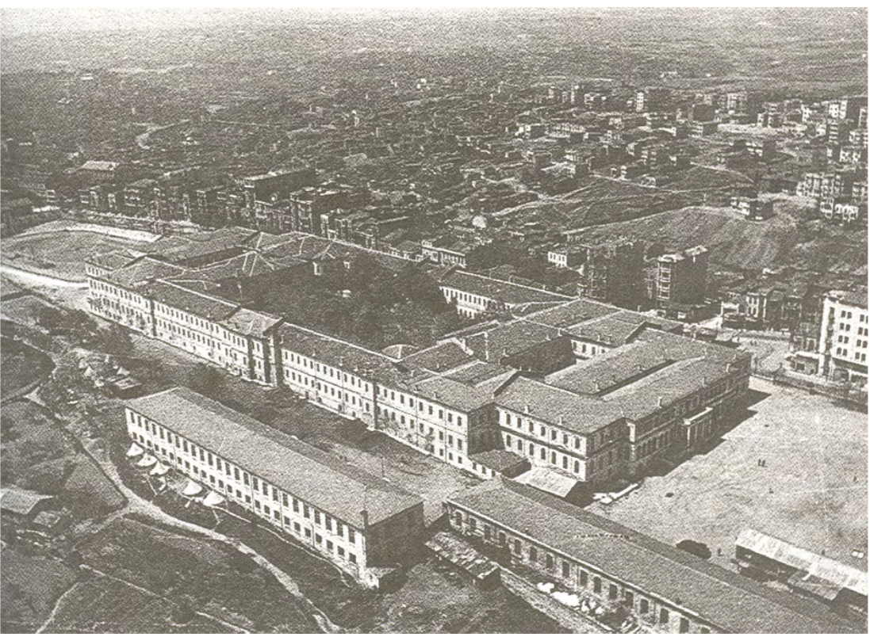

Pangalti Region, Late 19th century

Due to the unbearable population increase in Pera, 272,800 m2 area accross the military school in Harbiye had been opened for development with an imperial decree in 1848, Zeynep Celik, Degisen Istanbul, Tarih Vakfi Yurt Yayinlari, Istanbul, 1996, p. 56
A database based on the property petitions given by the Italian citizens to the Italian consulate in Istanbul.
“Tünel’de taşınan yolcu sayısı 1880’lerden 1910’a kadar 2.700.00 ile 3.200.000 arasından değişmişti”. Murat Guvenc, https://archives.saltresearch.org/bitstream/123456789/184483/1/ECOBARCE039.pdf ,
Galata ve Pera’nın Toplumsal Coğrafyasındaki Değişme: 1910-1922 Doğu Yıllıkları Üzerinde Çözümlemeler, Murat Guvenc, https://archives.saltresearch.org/bitstream/123456789/184483/1/ECOBARCE039.pdf ,
Ayşe Derin Öncel, Apartman, Kitap Yayinevi, Istanbul, 2010, p. 14

